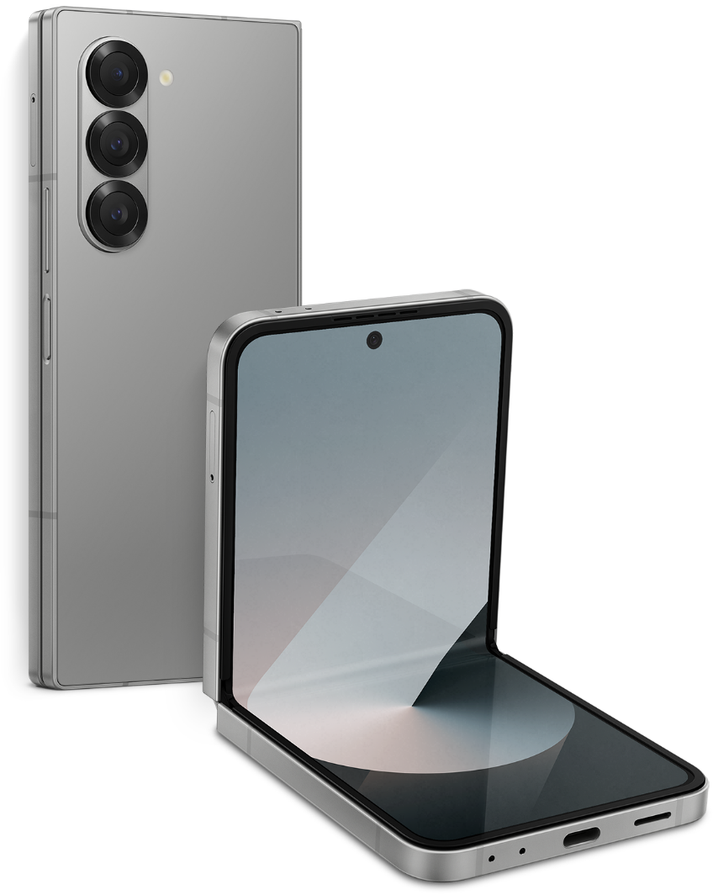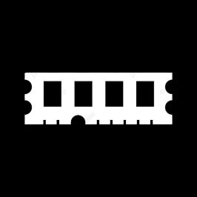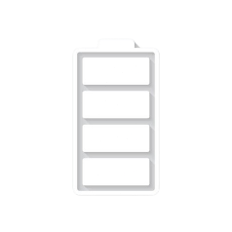

Price: $ 1,129

GALAXY Z FOLD 6

* Processor: Qualcomm SM8650-AC Snapdragon 8 Gen 3 (4 nm)
* Front Camera:4 MP
* Rear Camera:50 MP
* Display:7.6 “
* NFC: Yes
* Colors: Navy, Silver Shadow, Pink, Black, White
* Operating System:

Android 14

* Charging Type:USB Type-C
* SIM: Up to two Nano-SIM and multi eSIM
* Fingerprint:Yes
* Release Date: 2024, July 10

RAM

12

GB

ROM

01

TB

BATTERY

4400

mAh



+001-28272300-2466-2469



webmaster@cellinfo.com



A-65, ACME Co. ,

Street No. 12,

New York

Ask Me Ltd.